

Systems Development: Object Oriented Programming

(H171 35)

WPF Application

Step 3 – implement the navigation from the main application window back to the initial “welcome” window

* Now that we have our screen layout and we can launch our main application page from the initial “welcome” window, let’s start with writing the code for the main application window – MainAppPage.cs
* First we will implement the “return to start page” button...
  + Add the event handler to the MainAppPage.cs

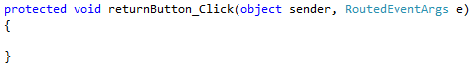

* + The event handler will create an instance of the initial “welcome” window (MainWindow, which we want to navigate back to) then call the show method to open it. It will then close the currently open window (this) using the close method

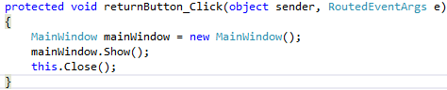

* We have created an event handler to instruct what happens when the user clicks on the “return to start page” button, BUT we have not linked this event with the button. We are going to want to set up lots of events for this main application page so let’s create a method where we add all the events for each of our page elements. Currently we will only be adding the event for our “return to start page” button element

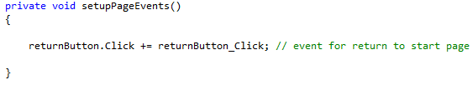

* Now we need to call this setupPageEvents method to setup each of the events for this page. We want this to happen when the page is launched, therefore we will add the method call to the end of our initializeWindow()

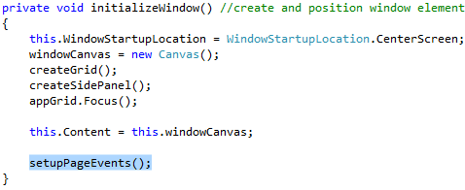

**STOP AT THIS POINT AND TEST THE BUTTON NAVIGATION ON THE APP!**